* 1. A) A table that is based on Table 1 with the information of your project and the organization of the team.

|  |  |  |  |  |  |  |  |
| --- | --- | --- | --- | --- | --- | --- | --- |
| Name of the Team (Project) | | | Concursos | | | | |
| Link to the public GitHub repository | | | <https://github.com/carlosdgt95/ISII-WORKSHOPS-CONCURSOS.git> | | | | |
| Name of the teams members | For each member of the team mark all the roles the members played in this workshop | | | | | | |
| Repository Owner | Tester | Documenter | Class developer | Setters developers | Getters developer | Premium calculation developer |
| Castro Karla |  |  |  | X |  |  | X |
| Gomez Carlos | X | x | x | X |  |  |  |
| Farias Stefany |  |  |  | X | X | X |  |

B) A screen capture of your Gradle project, showing the Package Explorer view (expanding the *src/main/java* folder) and the code of the *CarInsurace* class.

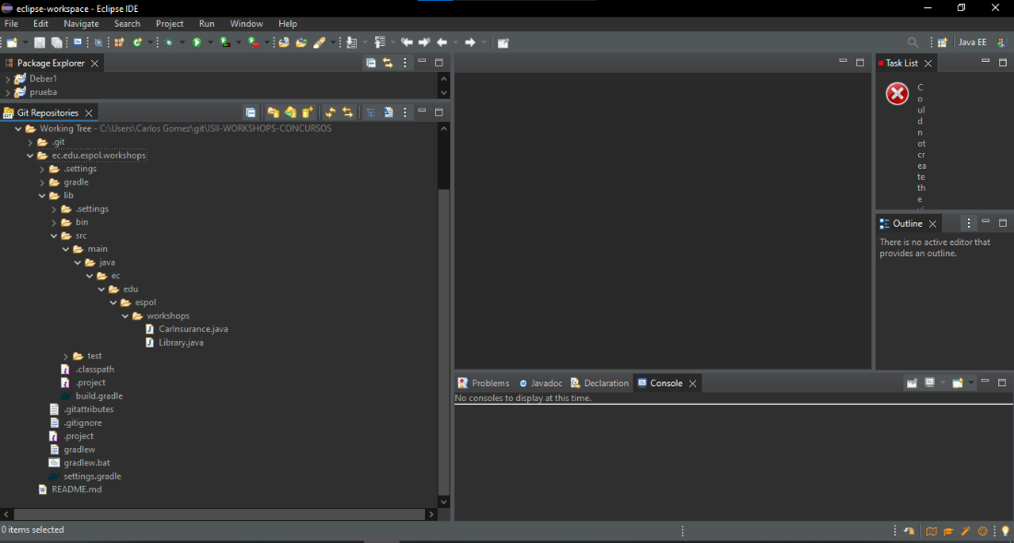

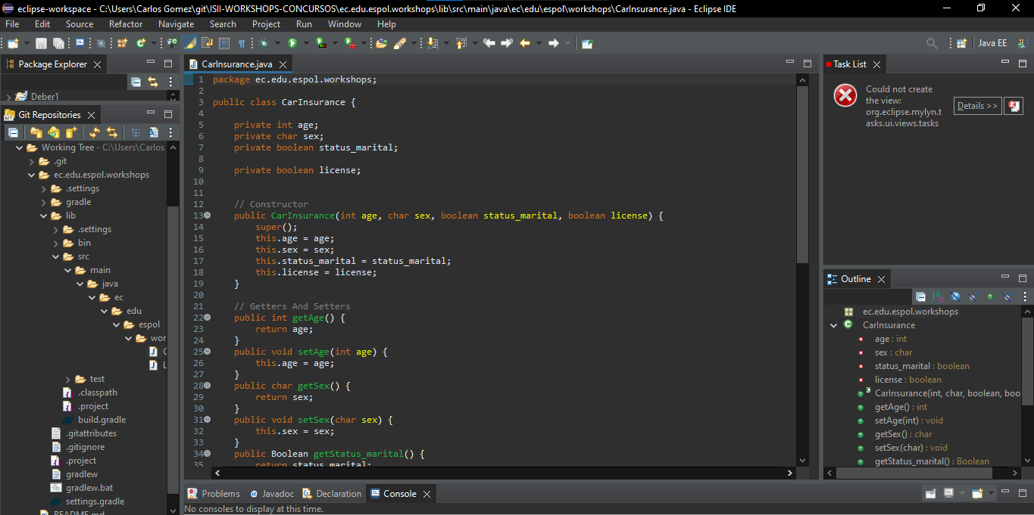

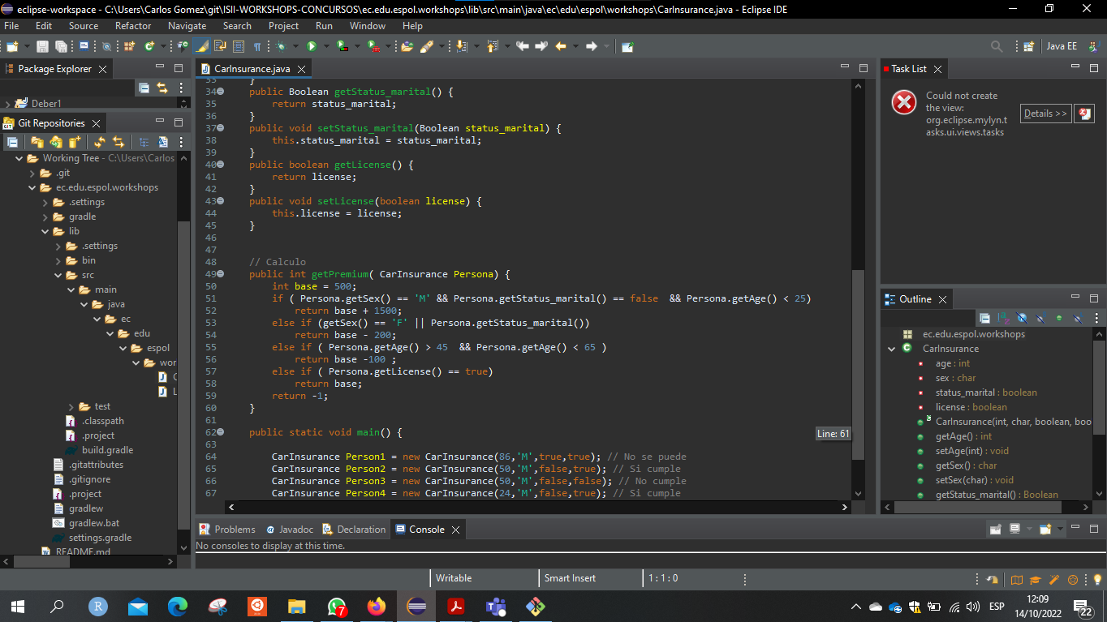

1. A screen capture of the codeline of your project. You can either obtain it from Github, or you can right click on your project in the Eclipse IDE and

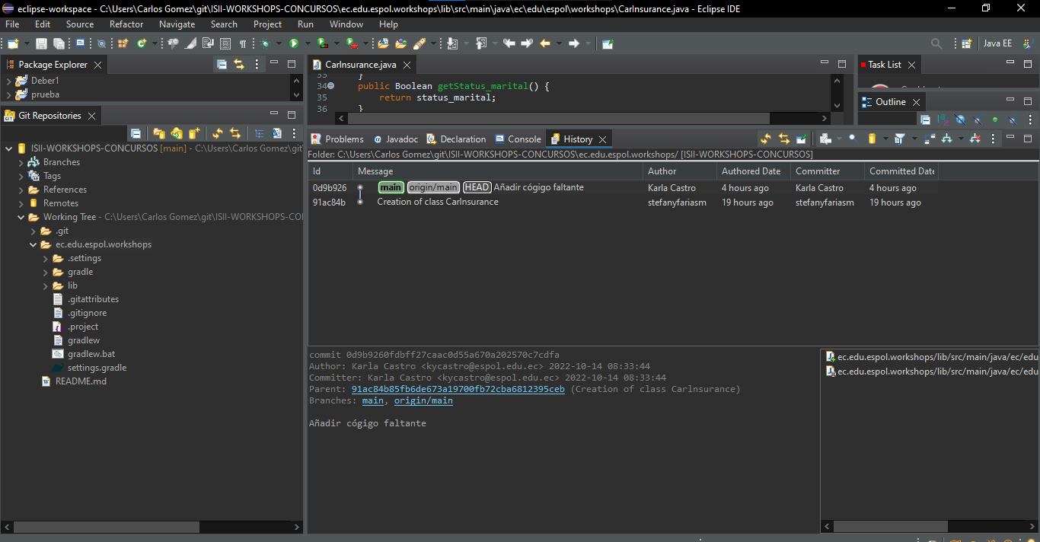

D) A screen capture of the console and the Gradle Executions view after the successful build.

